

Weekly Overview – Week Beginning 19.3.18

Here is an overview of some of the activities we will be doing this week, in whole class and small groups.

Man On The Moon

We are getting ready for our trip to the moon

[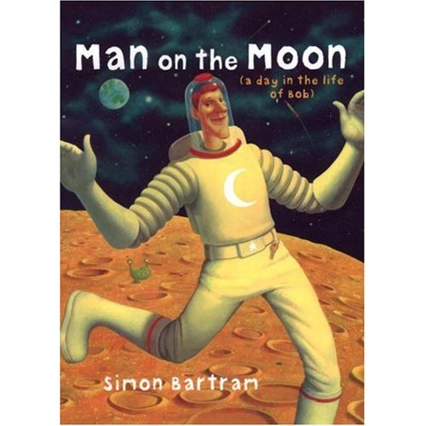](https://www.google.co.uk/url?sa=i&rct=j&q=&esrc=s&source=images&cd=&cad=rja&uact=8&ved=2ahUKEwiW_7qVrvDZAhUCWRQKHc_oCVgQjRx6BAgAEAU&url=https://www.goodreads.com/review/show/320910230?book_show_action%3Dtrue%26from_review_page%3D1&psig=AOvVaw1_1l-WXIfLHjCaM1AlXoka&ust=1521273103698169)

**Maths**

## This week we will be practising recognising numbers 10 –20, using Numicon and playing games. We will also look at various pictoral representations of these numbers, to help develop the children’s understanding of their values.

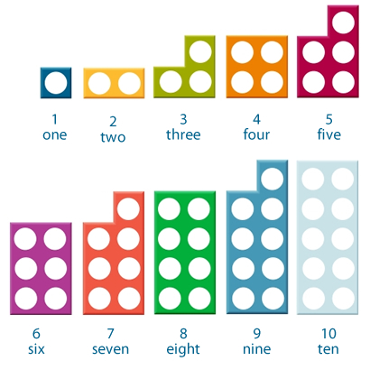

**Letters and Sounds**

Letter and Sounds This week we will be learning the sounds: th (this/ thin) We will also consolidate the sounds ch and sh, by playing lots of games which involve reading and writing words containing these sounds.

