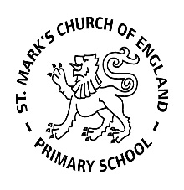

Weekly Overview – Week Beginning 12.3.18

Here is an overview of some of the activities we will be doing this week, in whole class and small groups.

Getting Ready For Our Space Assembly 20th March 10am

All Children Have Had Their Parts Sent Home



**Maths**

## This week we will be practising recognising numbers 10 –20, using Numicon and playing games. We will also look at various pictoral representations of these numbers, to help develop the children’s understanding of their values.

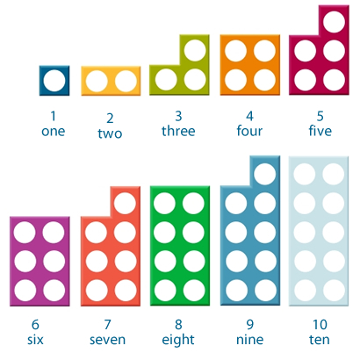

**Letters and Sounds**

**This week we will be learning the sounds: Z (zebra) and qu (queen) We teach the children that there are 2 letters in the sound ‘qu’ which work together to make one sound.**

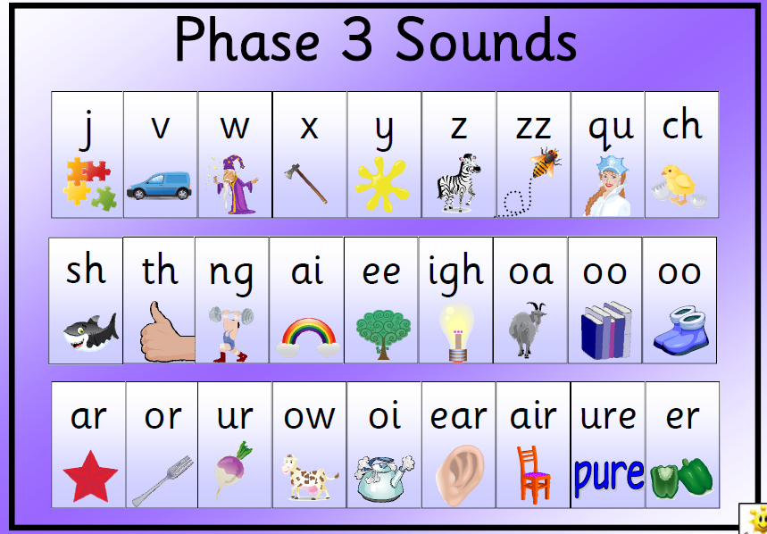

This week we will be introducing letter families

[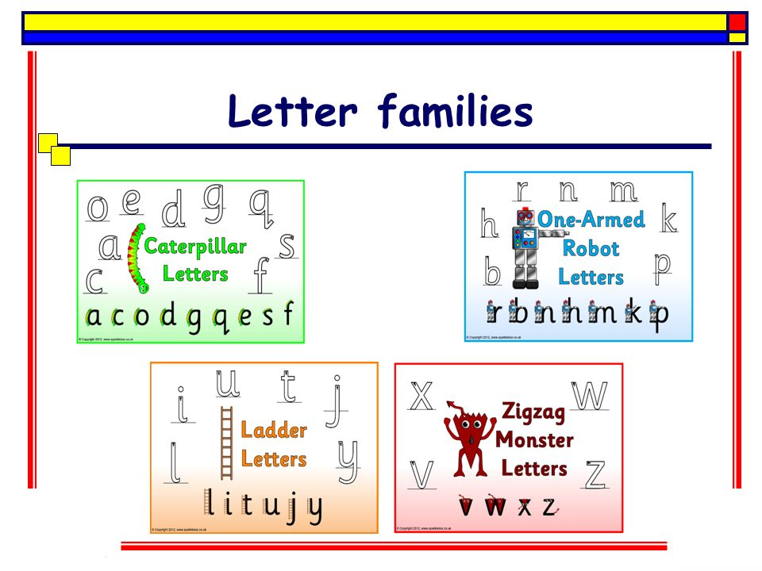](http://www.google.co.uk/url?sa=i&rct=j&q=&esrc=s&source=images&cd=&cad=rja&uact=8&ved=0ahUKEwjvwL7fntzZAhXBvRQKHfr6DuMQjRwIBg&url=http://slideplayer.com/slide/8969087/&psig=AOvVaw0oiN7I0IQIu34pwvZqhyy-&ust=1520581774631460)