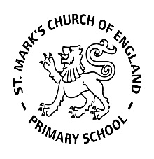

Weekly Overview – Week Beginning 29.1.18

Here is an overview of some of the activities we will be doing this week, in whole class and small groups.

Topic

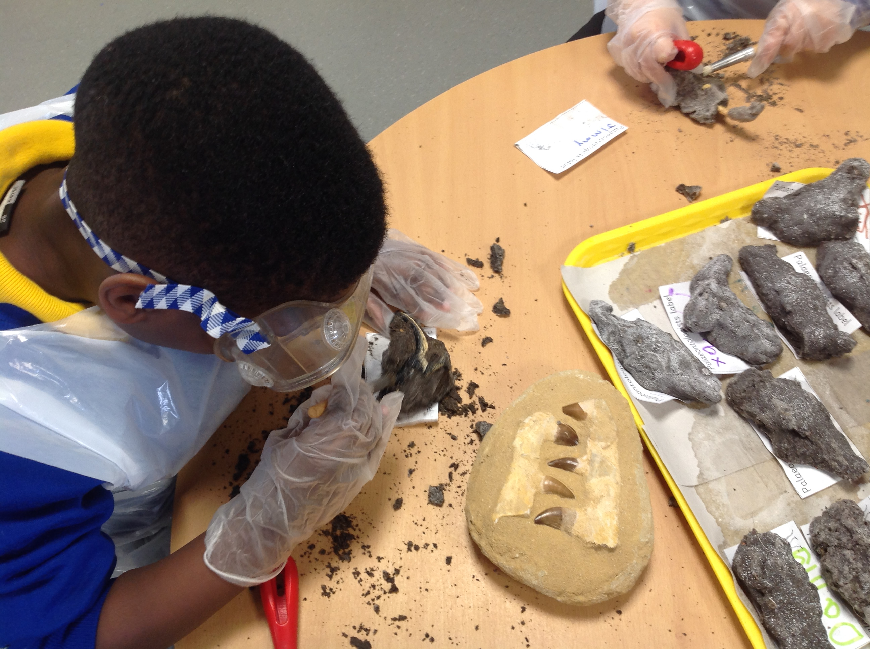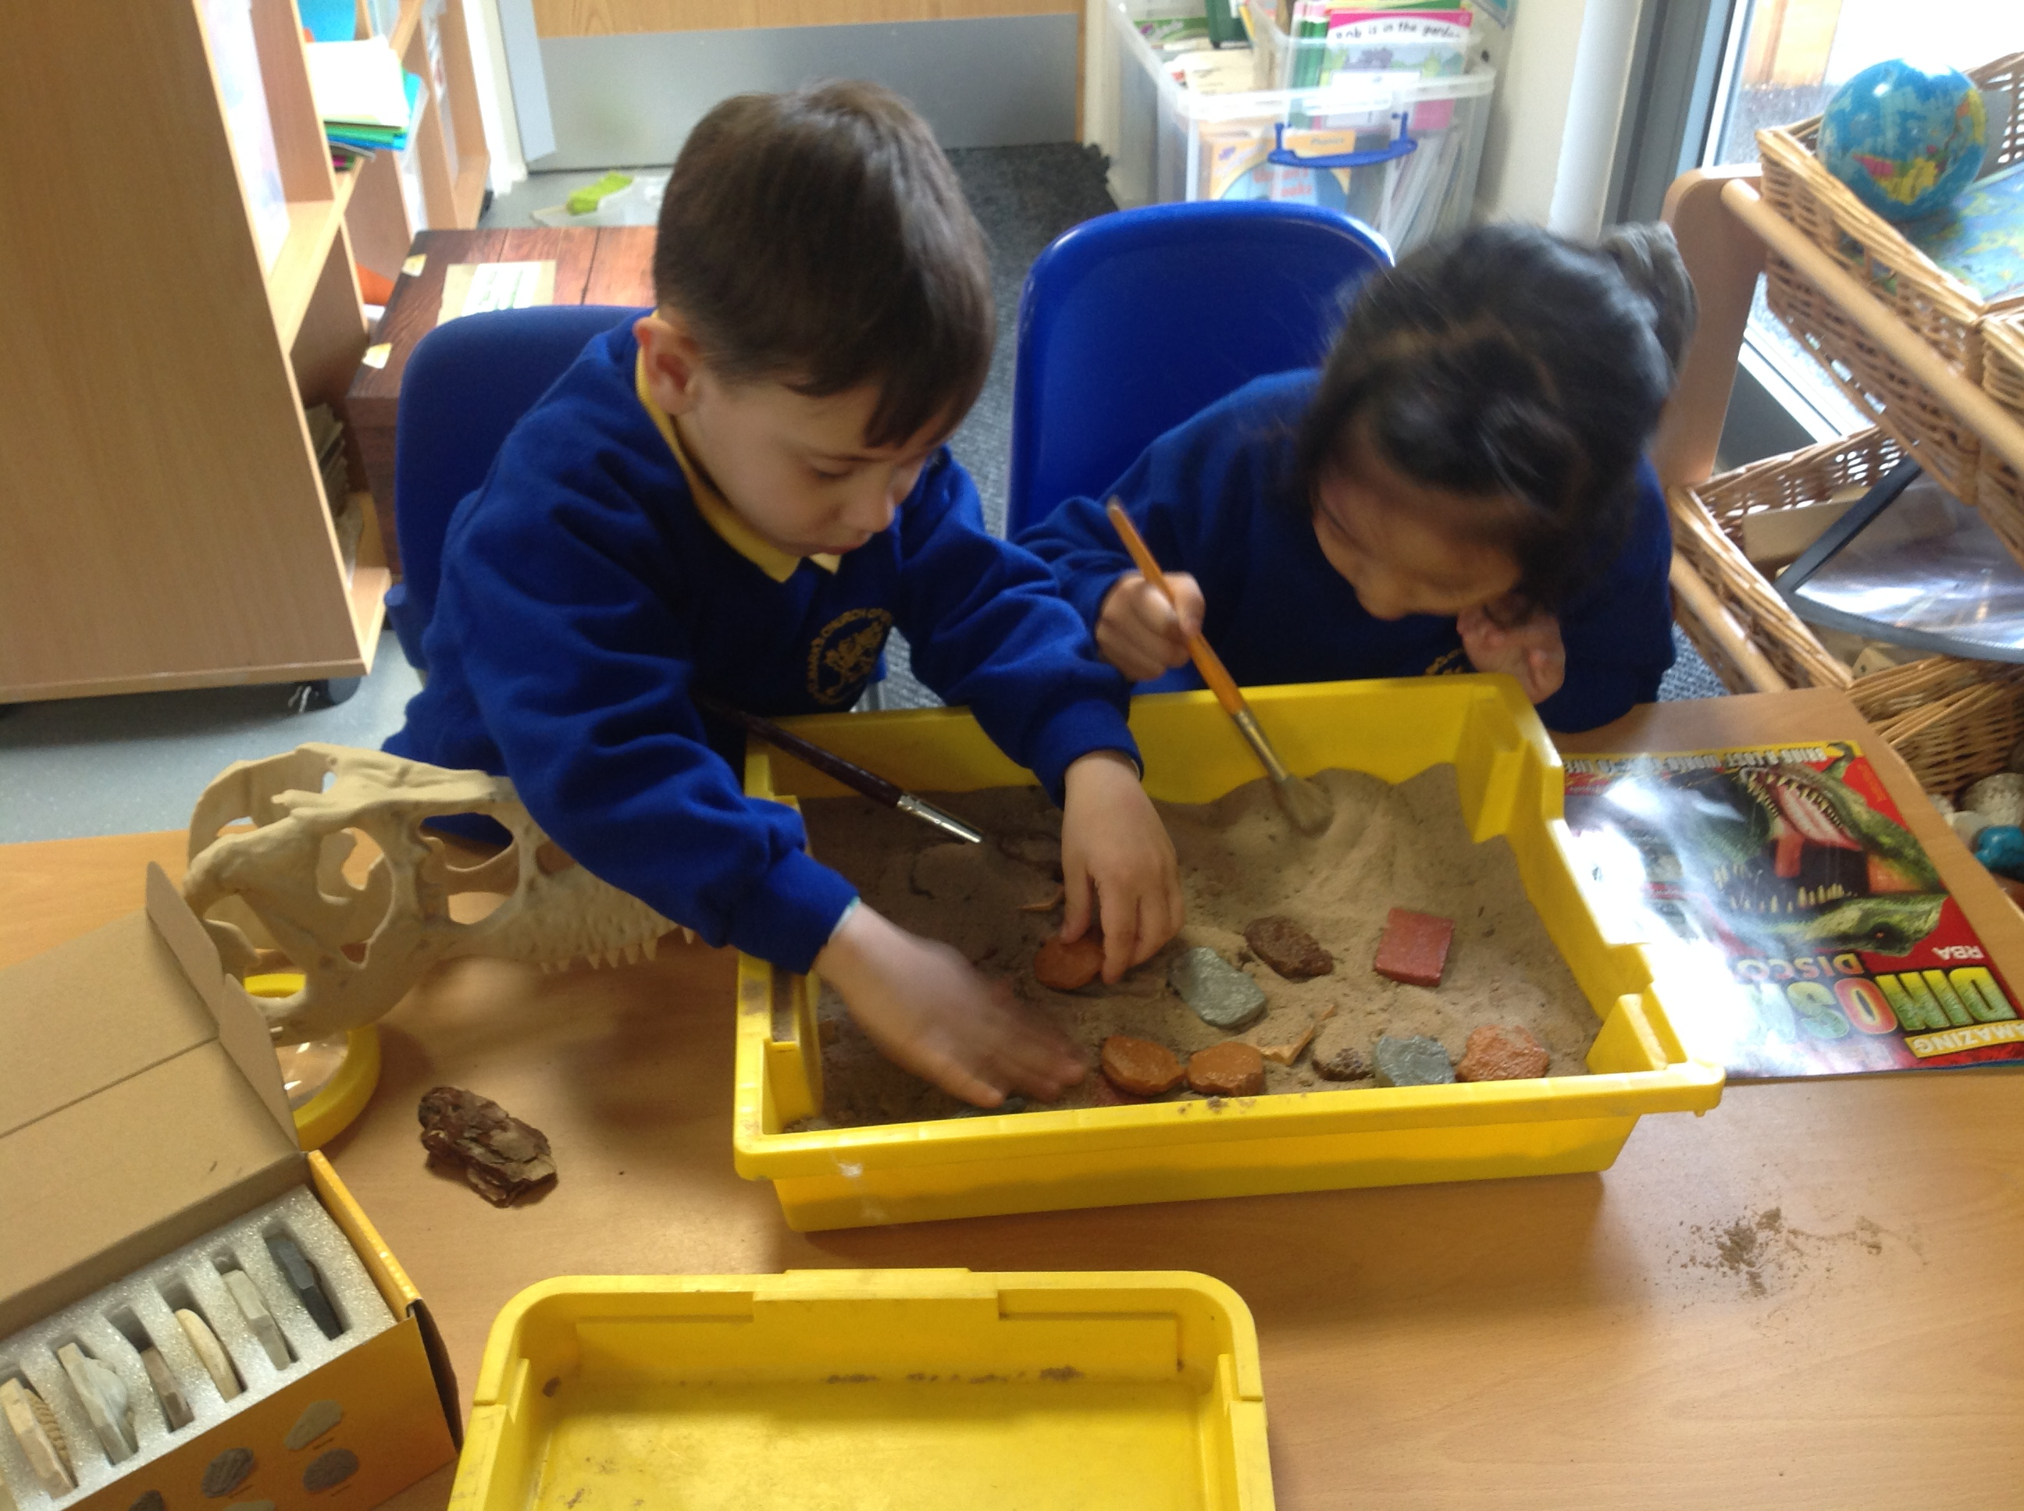

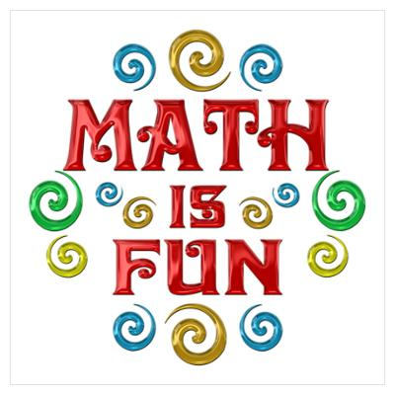

This week we are focussing on weighing and measuring. We will be using lots of everyday language about size, length, height and weight. We will also be ordering items by length and weight. The children will have lots of opportunities to explore capacity with water and sand.

**Cooking**

Cooking is an authentic and motivating way for the children to experience lots of areas of learning, e.g: reading (recipes), writing (shopping lists), Maths, (measures, money, counting ingredients etc). In order to do this, we rely on donations so we can buy ingredients. If you are able to, please make **a termly £5 donation** to the class cooking money pot. Alternatively, we would really appreciate donations of kitchen staples—flour, sugar, butter, eggs, salt, etc. Thanks

**Letters and Sounds**

We have now completed Phase 2

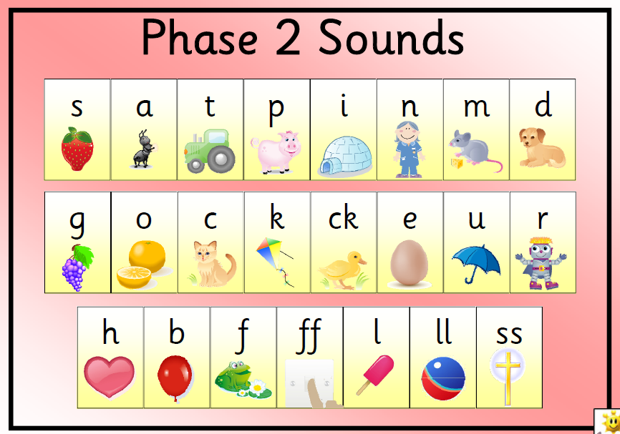

Spellings

All children now have a spelling book.