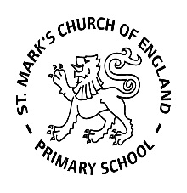

Weekly Overview – Week Beginning 14.1.18

Here is an overview of some of the activities we will be doing this week, in whole class and small groups.

**Topic**

This week we will be continuing to introduce our new topic all about dinosaurs. The children will be looking at the features of dinosaurs and creating their own dinosaurs.

This week we will be focusing on the story ‘A bucket full of dinosaurs ’by Ian Whybrow & Adrian Reynolds. We will be sequencing key parts from the story and talking about the different characters.

In small groups, we will then be talking about our thoughts and feelings about being a dinosaur, encouraging the children to take turns in the conversation and listen to each other, as well as come up with their own ideas. They will then have a chance to write and draw their own dinosaur.

**Maths**

This week we are focussing on counting and recognising numbers to 20, particularly focusing on numbers 11-20. We will use Numicon to help the children to understand the value of these numbers.

.



**Letters and Sounds**

This week we are learning the sounds ‘e’, u, ck’ and ‘r’. We will be looking at the written letters and thinking about words that start with these sounds. We will also begin to write CVC words, e.g: hat, cat, pen, and cap.

**Handwriting**

In our fine motor skills workshop this week, we will be practising writing the letter **e**. We encourage the children to start in the middle then complete the letter in one anticlockwise motion.

