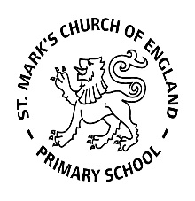

Weekly Overview – Week Beginning 04.12.17

**Here is an overview of some of the activities we will be doing this week, in whole class and small groups.**



In preparation for our show, we will be looking at the Nativity story. The children will be taking part in activities related to the Nativity and will be thinking about the different characters and their roles. We will also be practising all of our songs; please ask your child to sing a few for you at home.

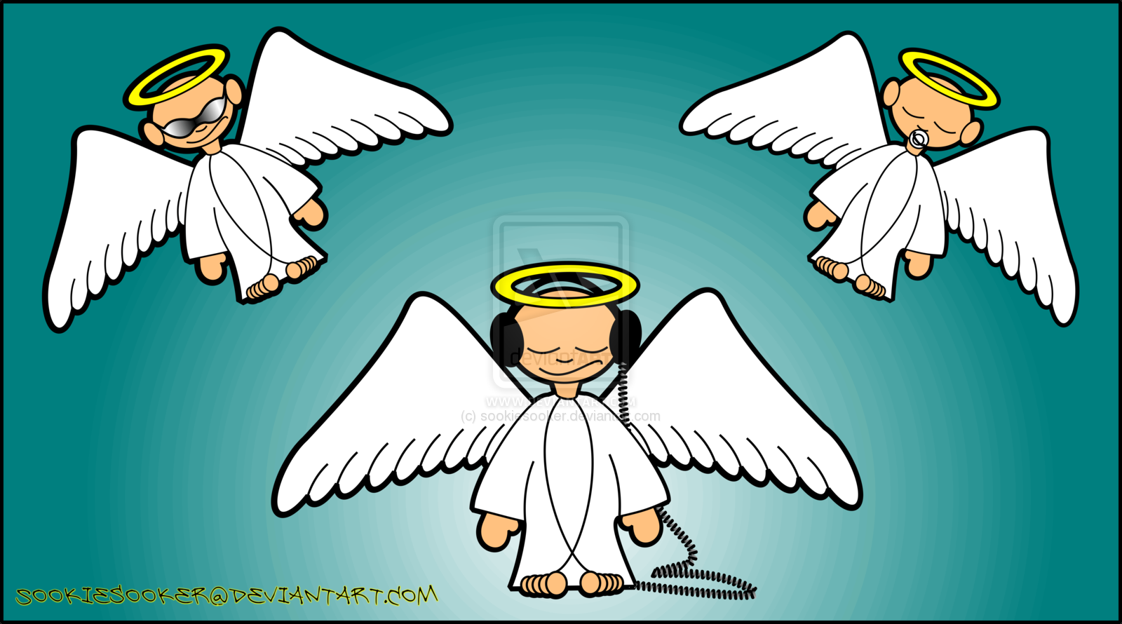

**Nativity**

Please bring in a pair of white tights, LONG white t-shirt and silver tinsel in a bag with your child’s name on by Friday 8th December.

**Winter Coats**

Now the weather is getting colder we have been helping the children to put on their coats by themselves. It would be great if you could

practise this at home too.

[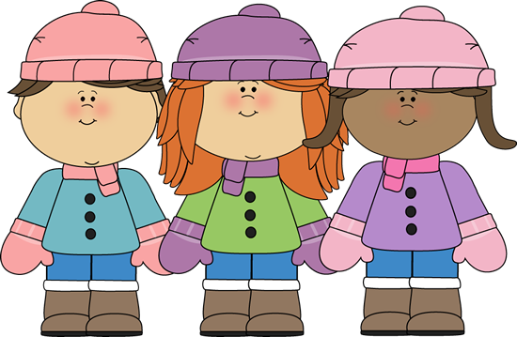](http://moziru.com/explore/Cold%20clipart%20winter%20coat/#gal_post_454_glove-clipart-winter-jacket-20.png)

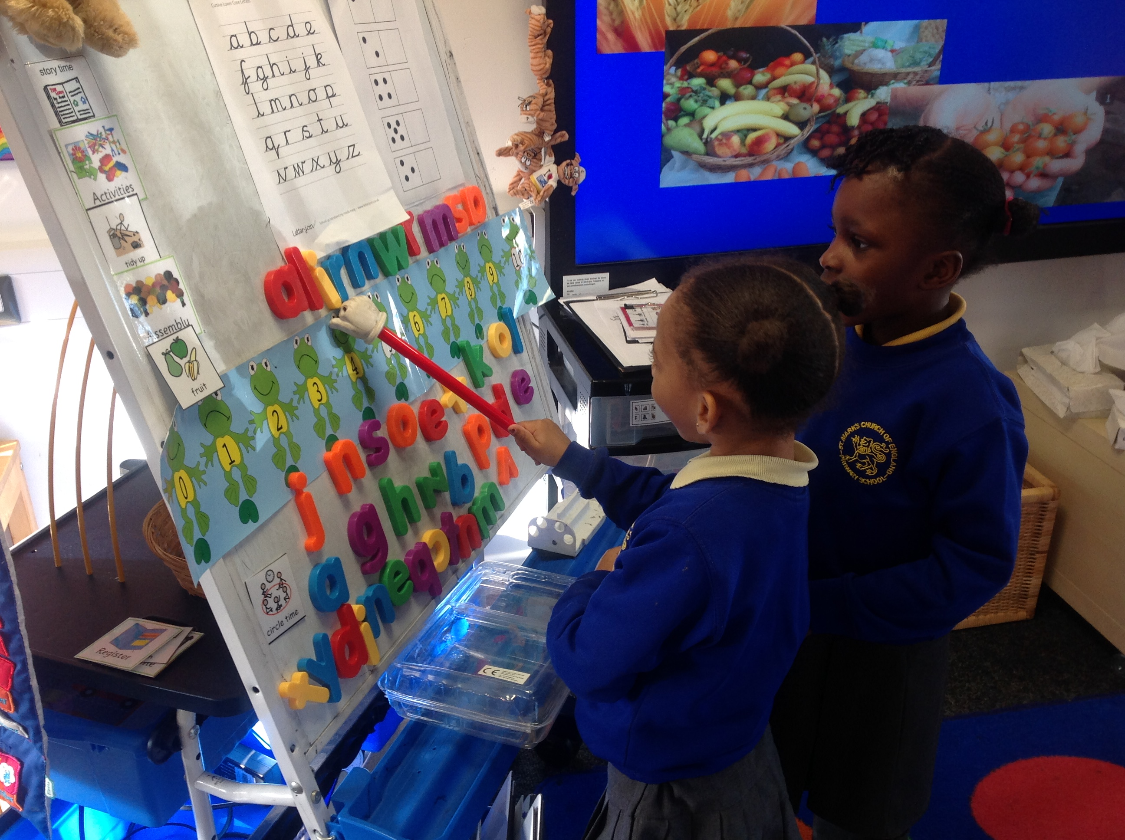

**Letter and Sounds**

This week we will be **CONTINUING** to revise all the sounds: **s, a, t i ,p, m, n, d** **g ,o** and **c, ck.**

We will also be revising the **tricky words**: **I, to, and the.** We teach the children that these words cannot be sounded out (as they do not follow phonetic rules), and so we have to just remember them. It helps to write them in **red** so the children remember this rule.