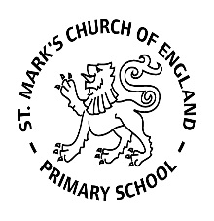

Weekly Overview – Week Beginning 27.11.17

**Here is an overview of some of the activities we will be doing this week, in whole class and small groups.**

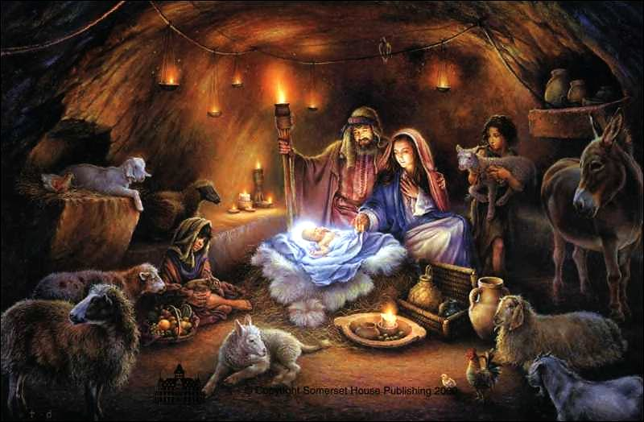

This week will be introducing the Christmas Story



**Nativity**

This week we are learning new songs for the Nativity. Emerald Class are all going to be angels. We are asking parents to bring in a pair of white tights, LONG white t-shirt and silver tinsel in a bag with their child’s name on.

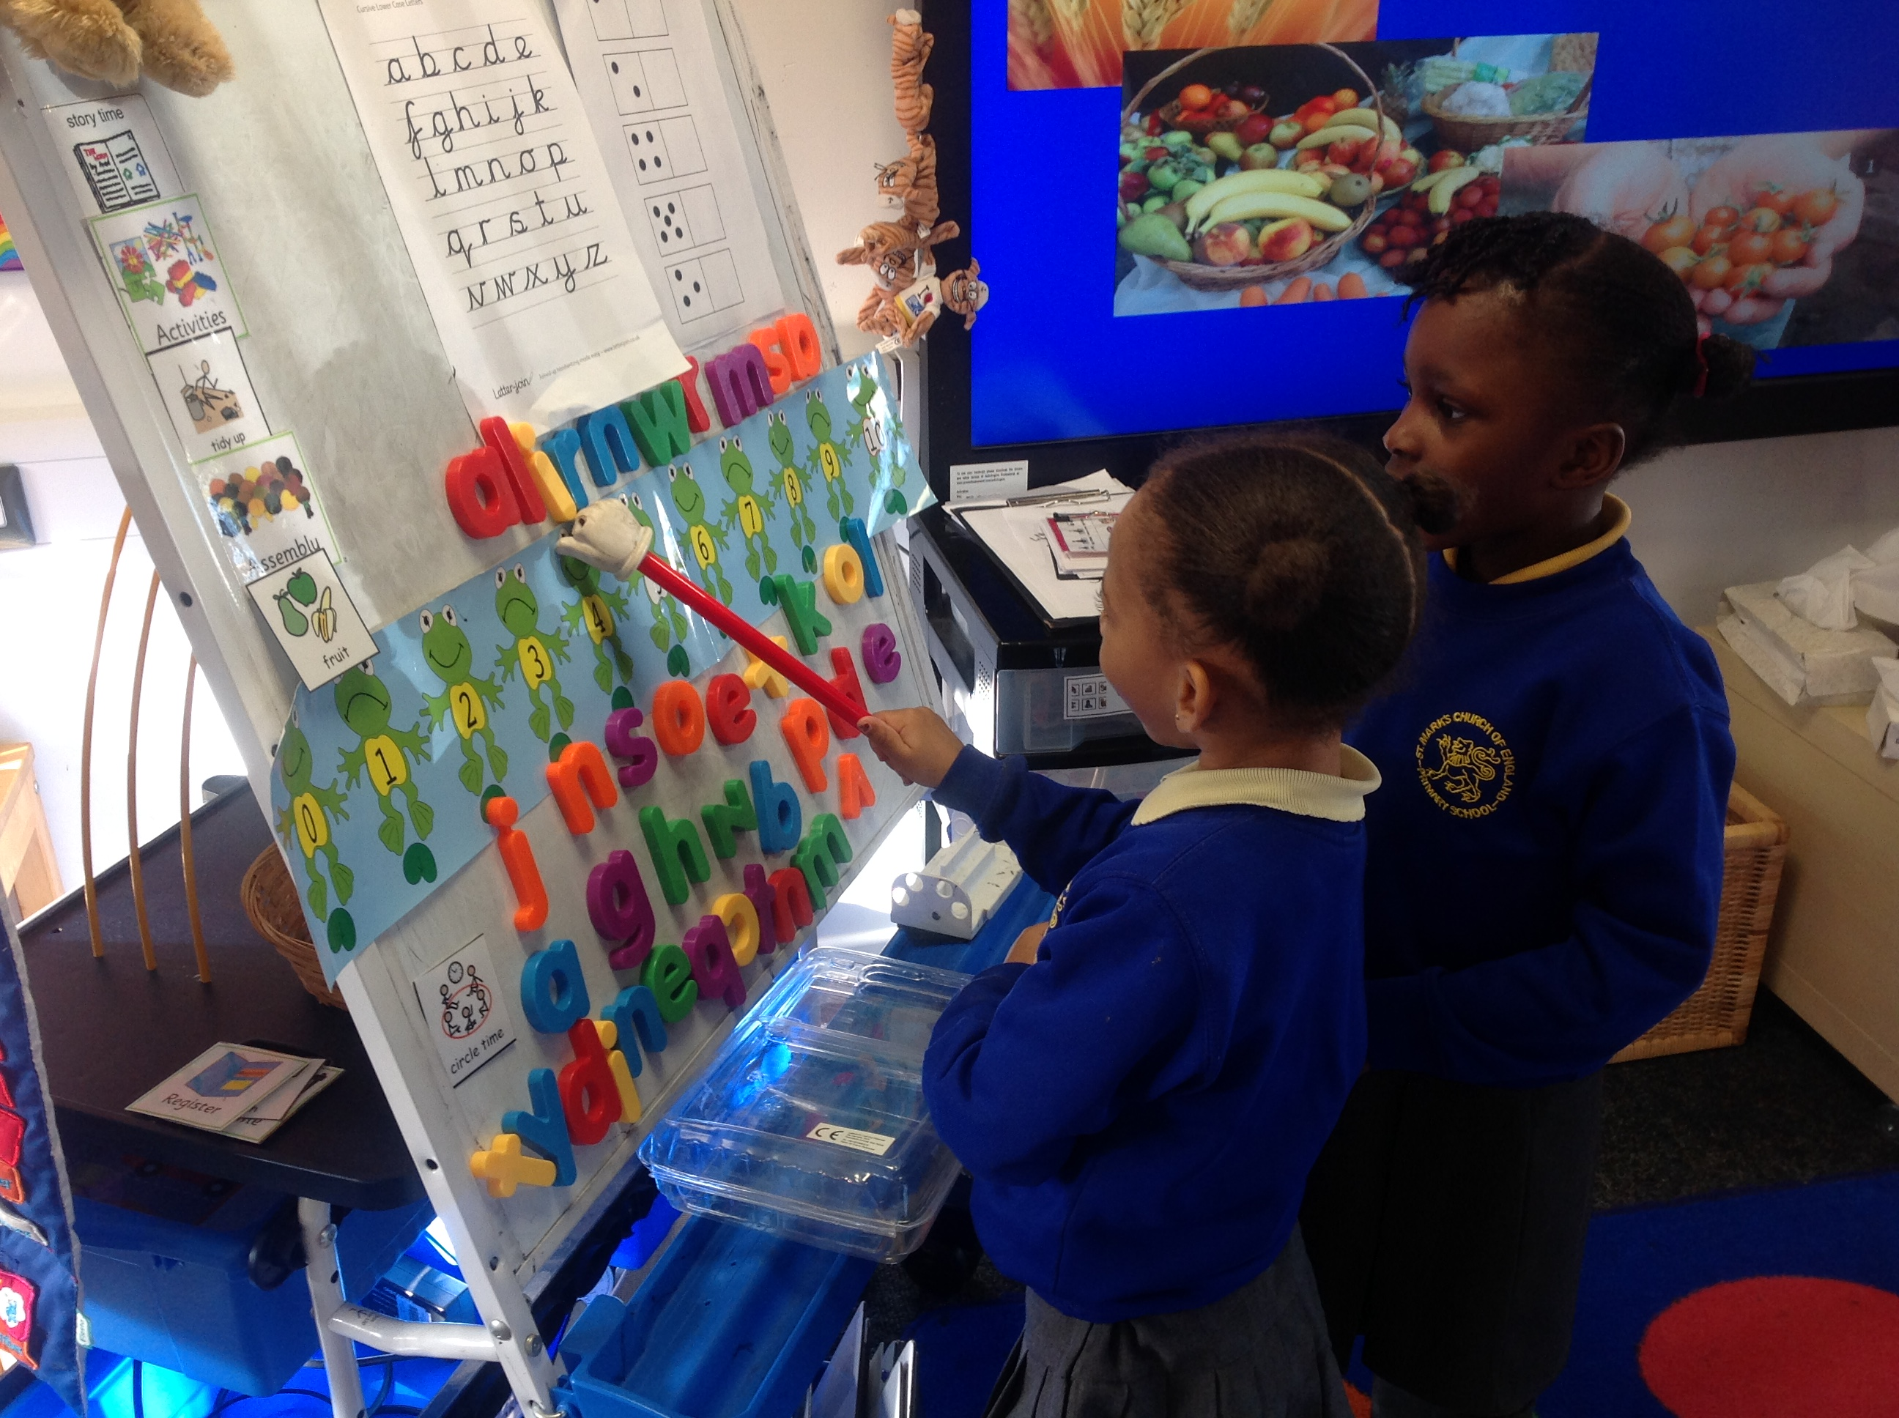

**Letter and Sounds**

This week we will be revising all the sounds:

**s, a, t i ,p, m, n, d** **g ,o** and **c, ck.**

We will also be revising the **tricky words**: **I, to, and the.** We teach the children that these words cannot be sounded out (as they do not follow phonetic rules), and so we have to just remember them. It helps to write them in **red** so the children remember this rule.