

Weekly Overview – Week Beginning 20.11.17

**Here is an overview of some of the activities we will be doing this week, in whole class and small groups.**

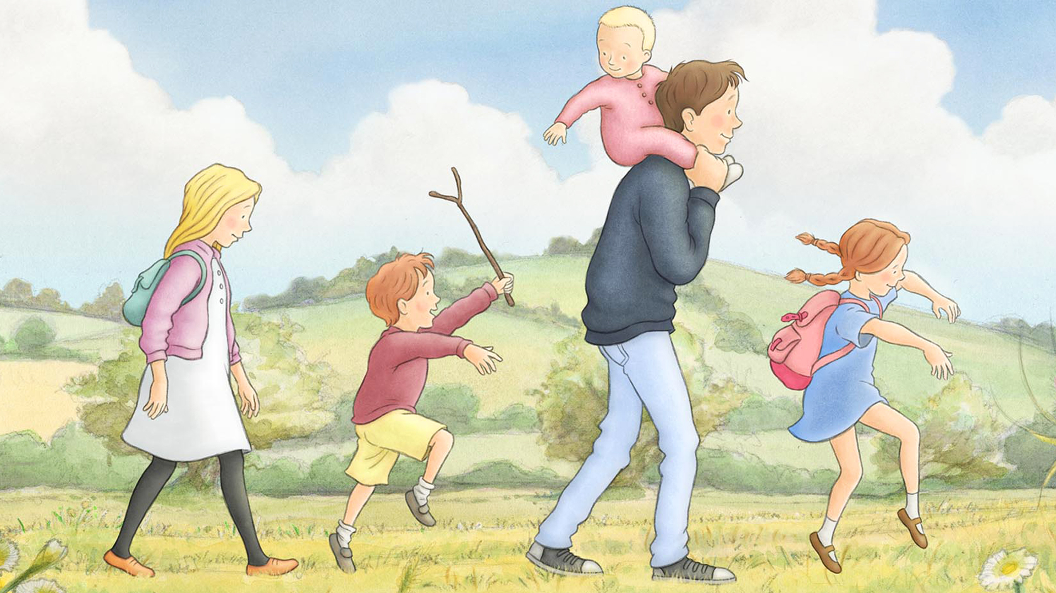

**Favourite Stories**

This week will be continuing to focus on the book ‘We`re Going on a Bear Hunt ’, by Helen Oxenbury. We have our assembly on Tuesday November 21st at 10am.

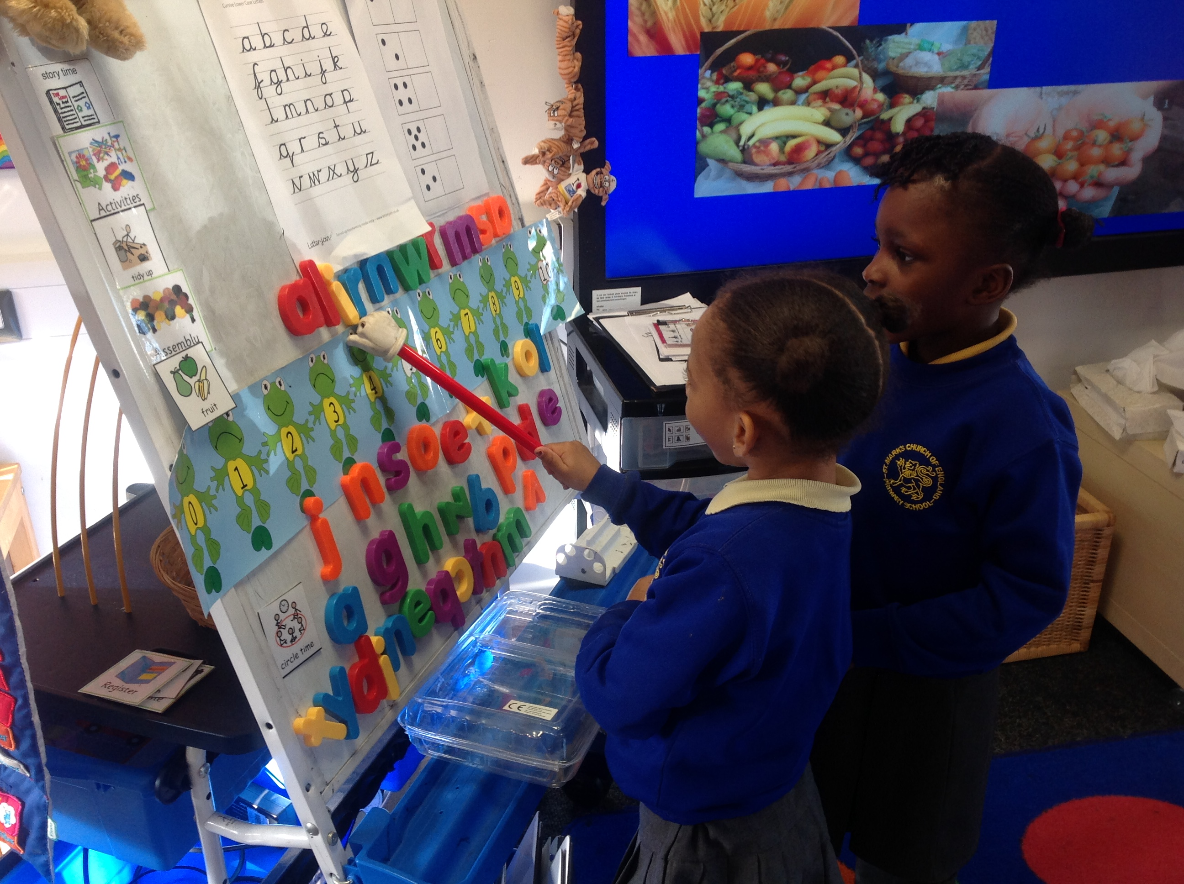

**Letter and Sounds**

This week we will be learning the sounds: **g, o** and **c, ck.**

We will also learn the **tricky words**: **I,** to**, into and the.** We teach the children that these words cannot be sounded out (as they do not follow phonetic rules), and so we have o just remember them.

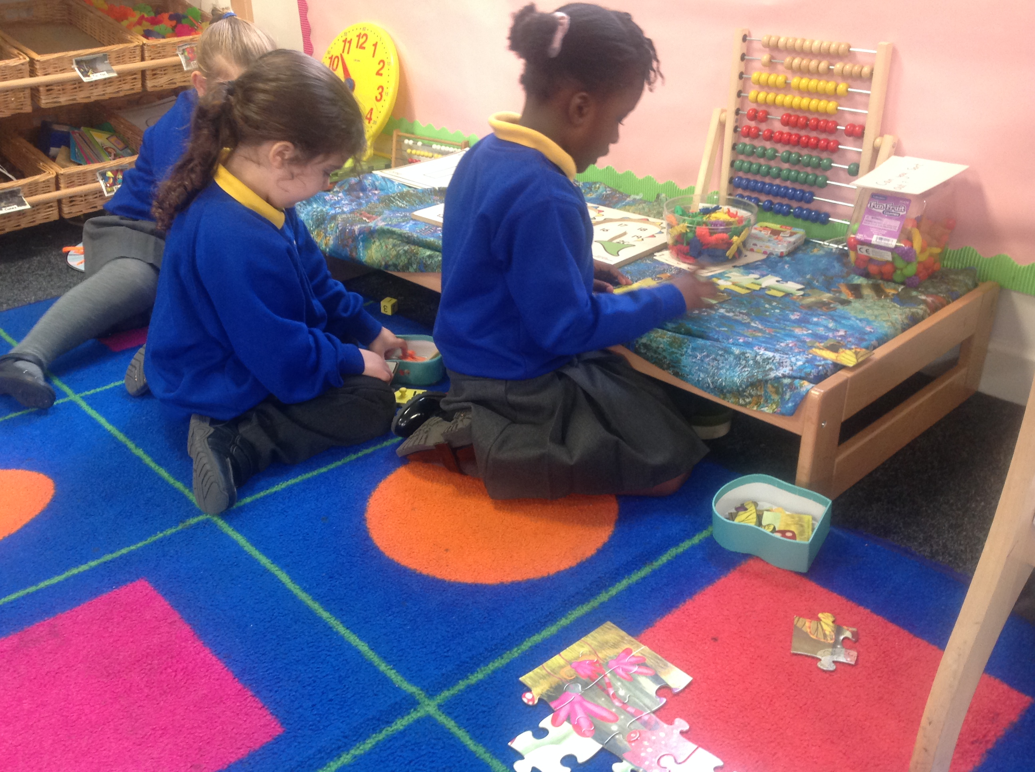

**Number**

This week we are focusing on accurate counting and recognising numbers to 20.