

Weekly Overview – Week Beginning 13.11.17

**Here is an overview of some of the activities we will be doing this week, in whole class and small groups.**

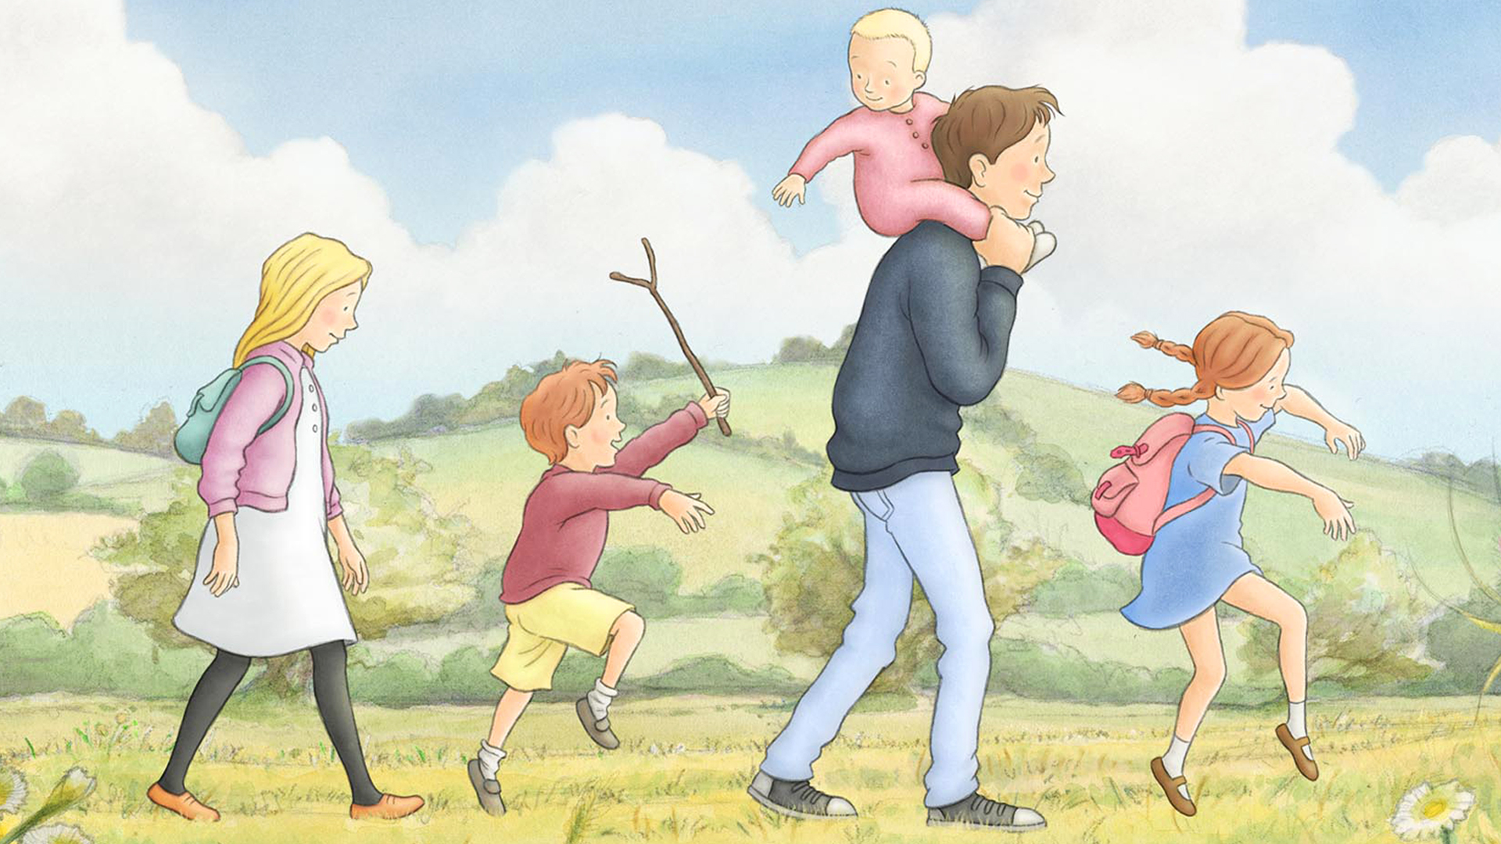

**Favourite Stories**

This week will be focusing on the book ‘We`re Going on a Bear Hunt ’, by Helen Oxenbury. We will practise the words and the rhythm of the story in preparation for our assembly on Tuesday November 21st at 10am. Please also continue to practise the poems given out for homework and the song Bear Necessities.

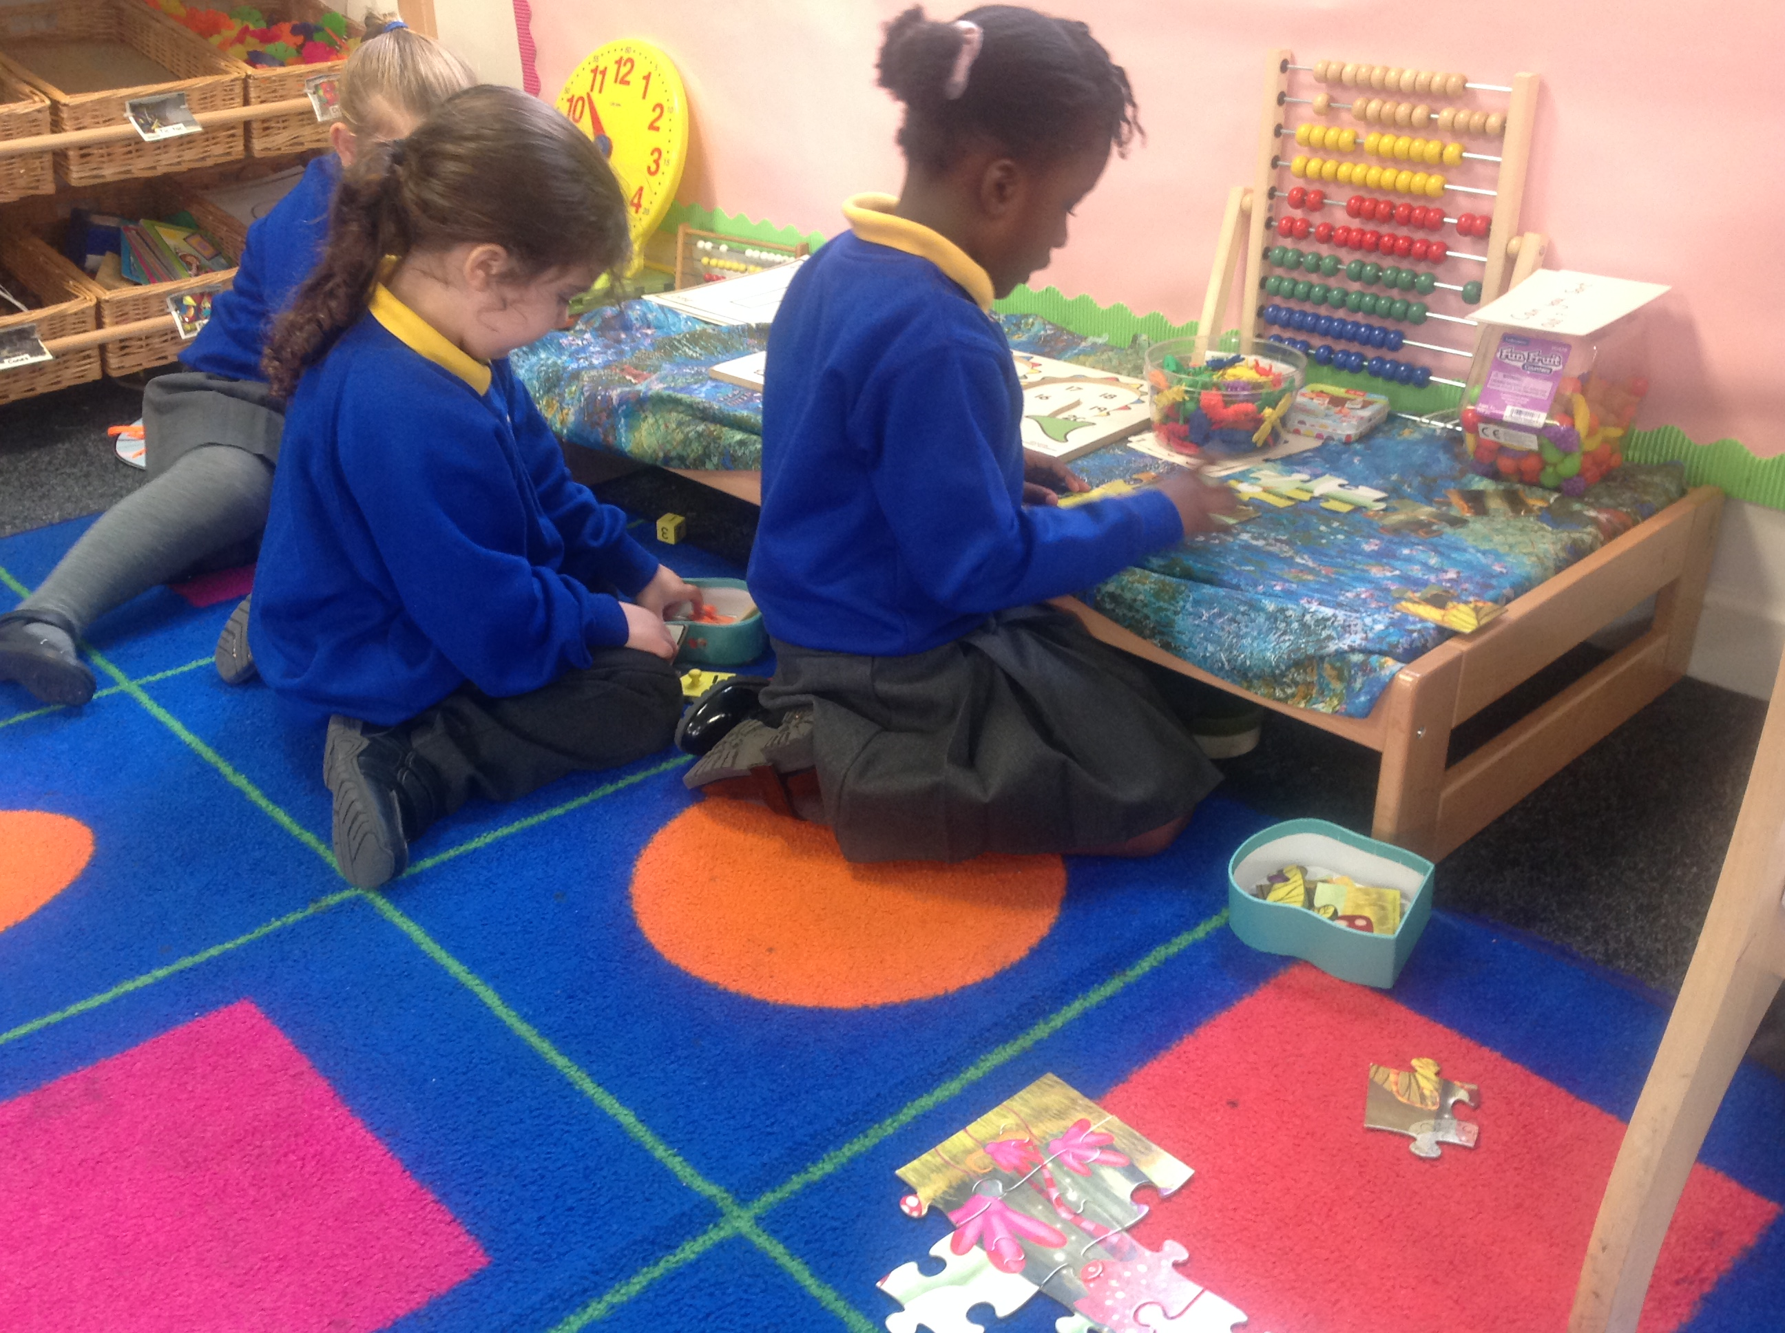

**Number**

This week we are focusing on finding one more and one less. We will be practising saying the number that is one more than a given number, and also practically finding one more or one less from a group of jungle animals.

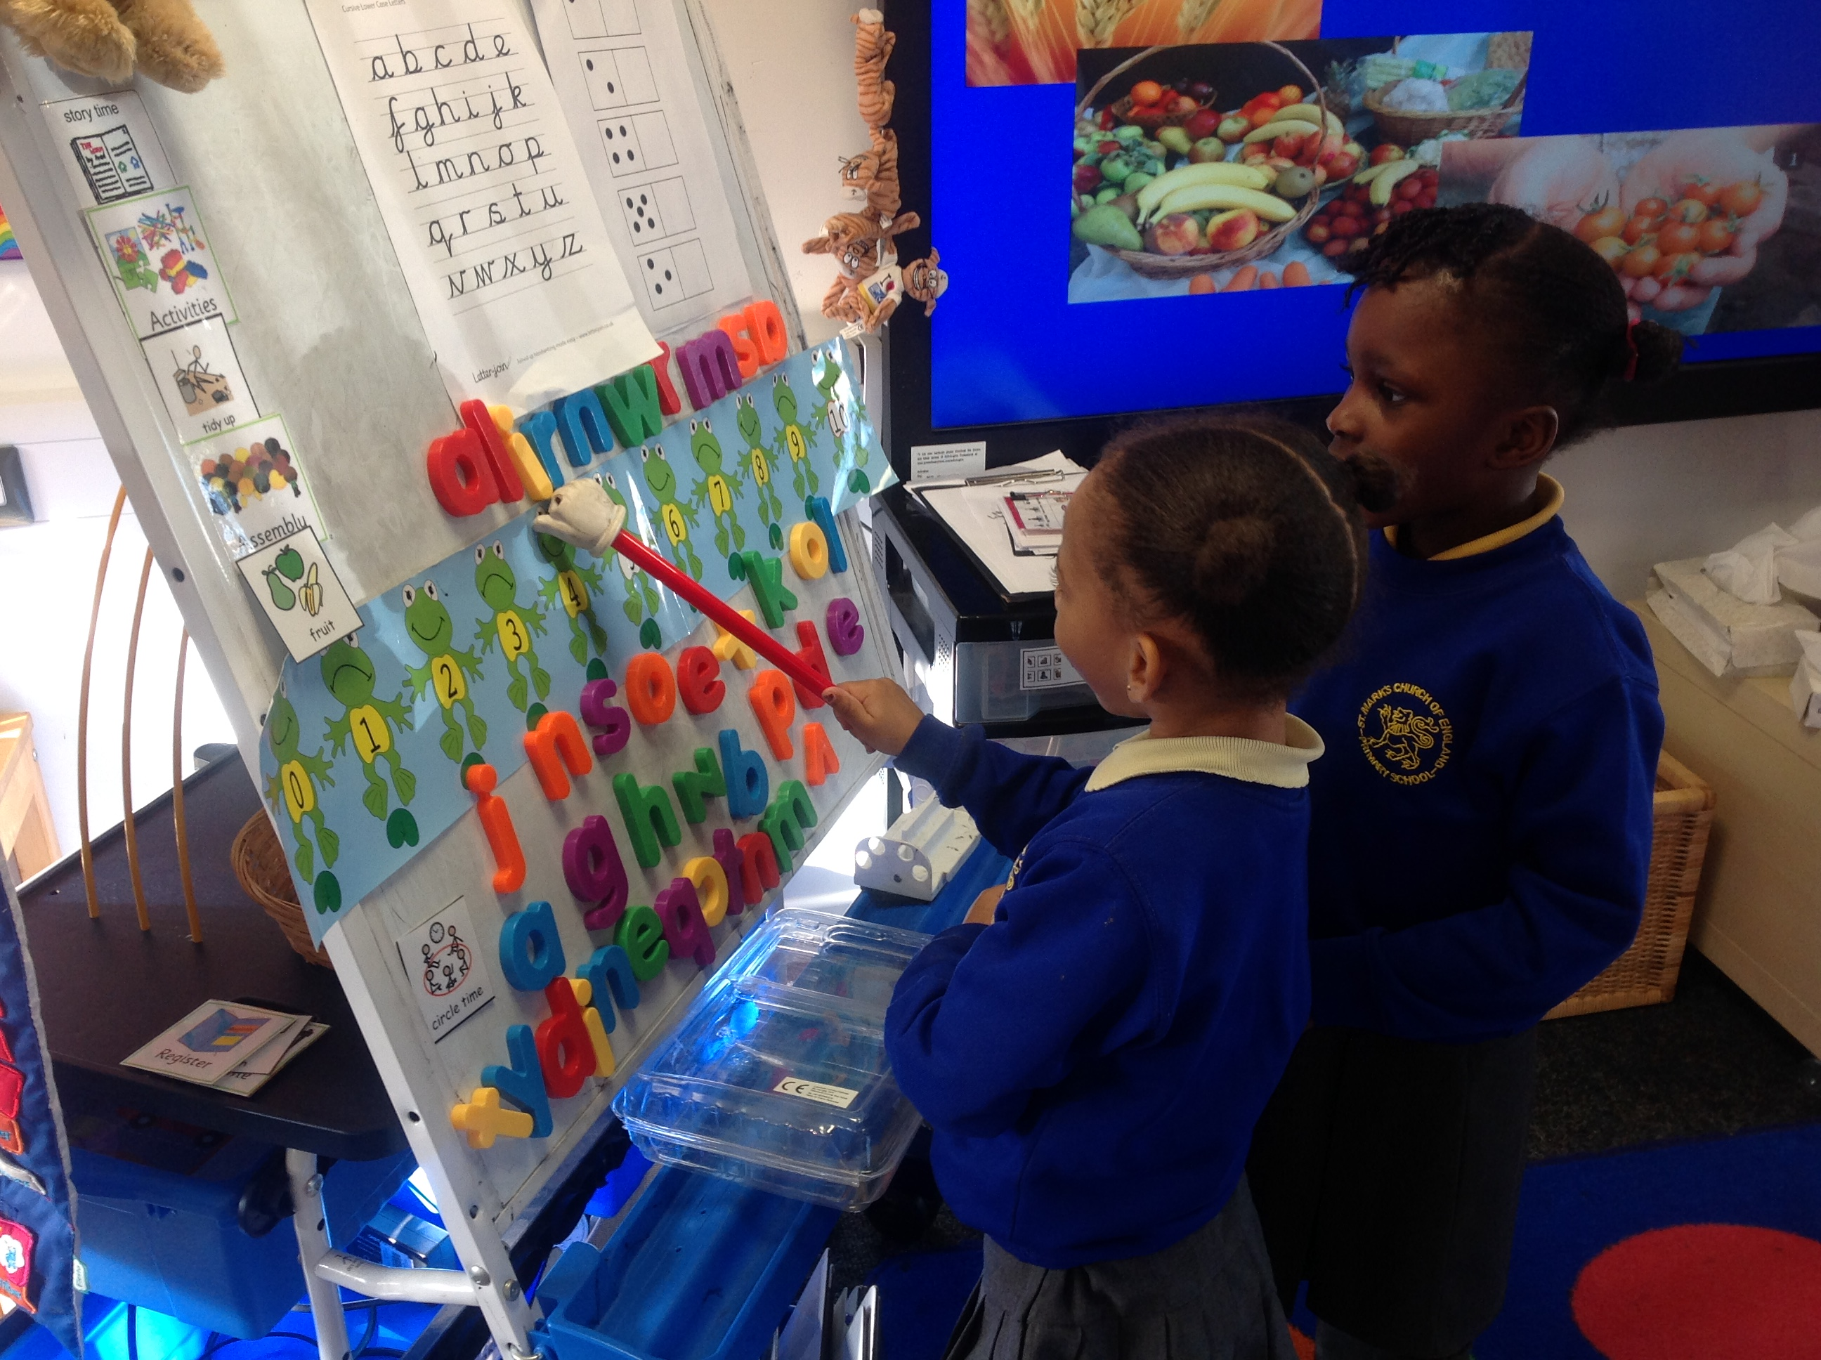

**Letter and Sounds**

This week we will be learning the sounds: **m, i** and **d.**

We will also learn the **tricky words**: **to** & **into.** We teach the children that these words cannot be sounded out (as they do not follow phonetic rules), and so we have o just remember them.